**MA 26600 Project 1: A Nonlinear Spring System**

1. As epsilon reaches higher and higher values, the amplitude of the system slowly decreases under 1, but above maybe 0.75. After an epsilon value of 0.6, the change is difficult to detect. As epsilon reaches greater and greater values, it takes a longer amount of time for equilibrium to be reached. The x value of µ+ seems to be 1.91 when epsilon is 0 and becomes 2.58853 after an epsilon value of 0.4. The change in µ+ becomes difficult to detect after an epsilon value of 0.4.
2. As epsilon reaches more negative values, the amplitude of the system slowly increases above 1. At first, the amplitude was 1, after epsilon was changed to -0.4, the amplitude was about 1.02138. This is quite clearly a slow and small change. As epsilon reaches more negative values, it takes less time to reach equilibrium. In the beginning, the x value of µ- was maybe about 4.29179. However, after an epsilon value of -0.4, the µ- had an x value of 3.137. So it took less time to reach equilibrium.
3. The value I found for ω* was 1.2. This ω* had an x value of 57.8886 and a y value of 2.57872.

Note: For some reason, my MATLAB online was refreshing constantly and kept giving me different answers and graphs to the same omega value.

Here are the photos of what I put into MATLAB for ode45:

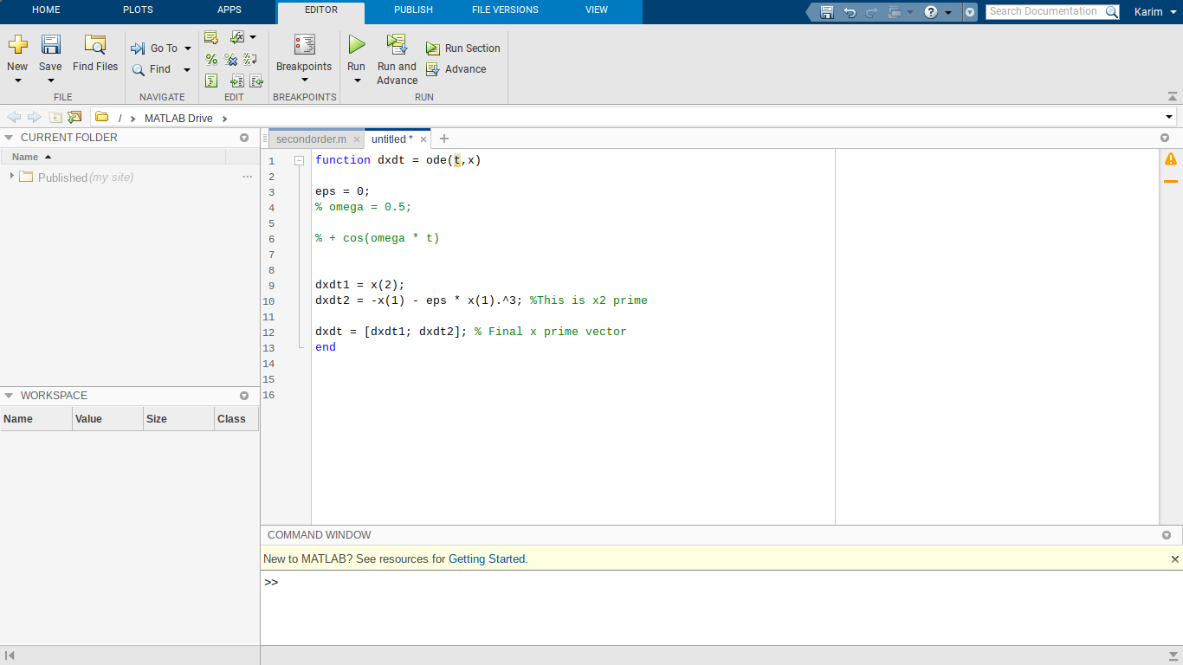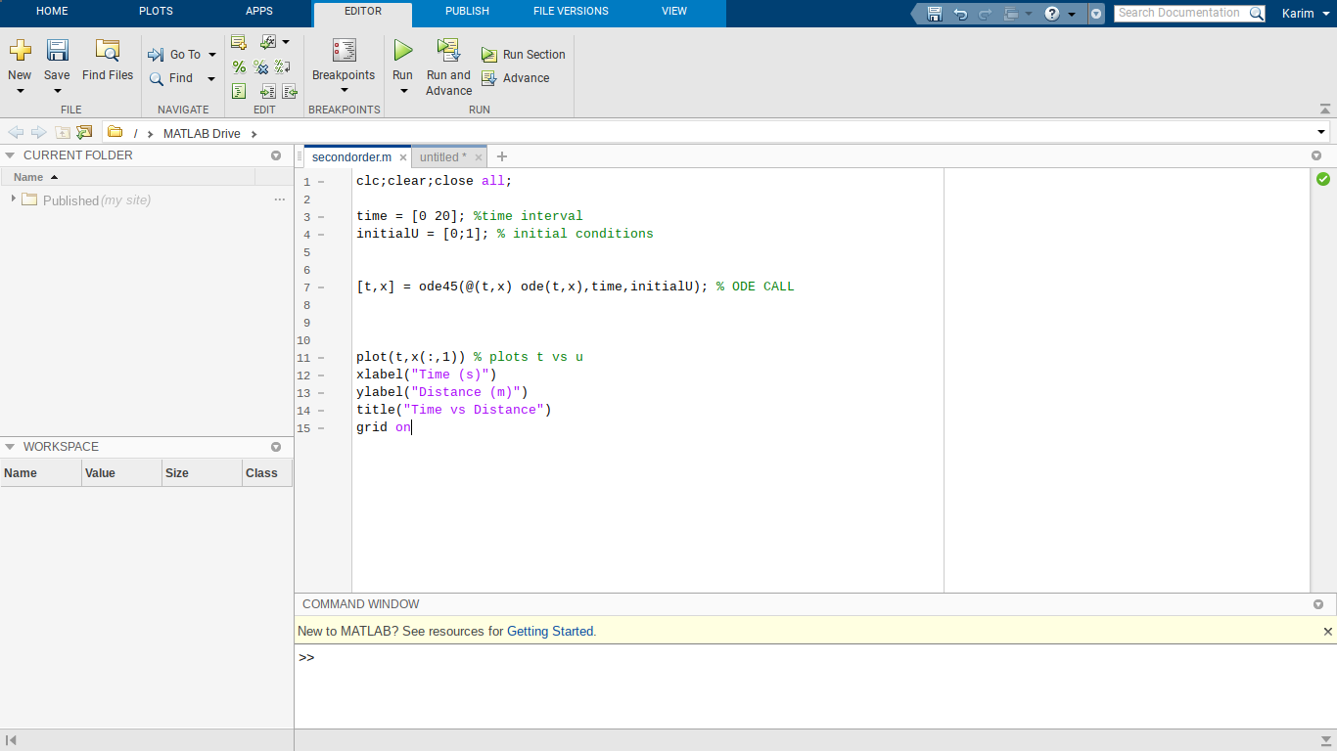

For #3, I change the time and initialU intervals and also changed the equation to: -((x(1))/5) - x(1) - ((x(1)^3)/5) + cos(omega * t)